A new folder has been created:

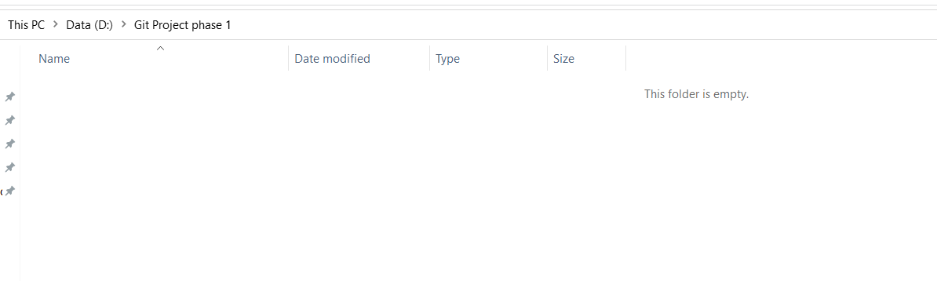

Git Bash is initiated:

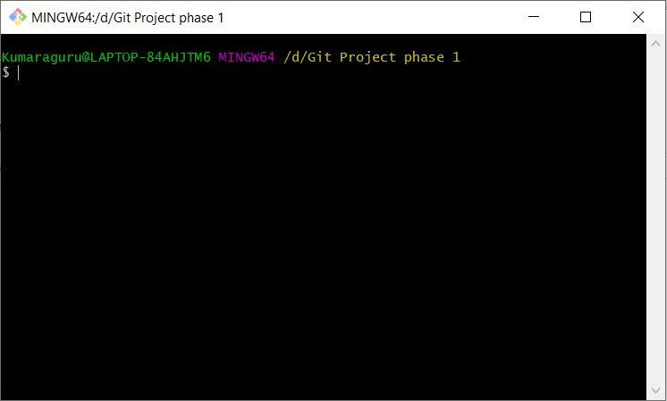

Command: Git init

To convert the folder to a GIT repository:

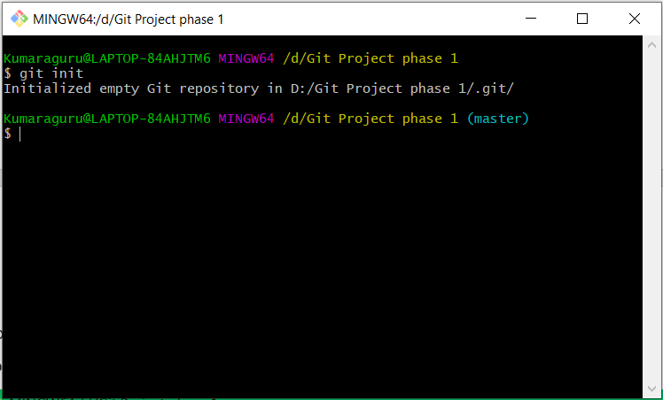

Command: Ls -la

To list out all the files in the repository

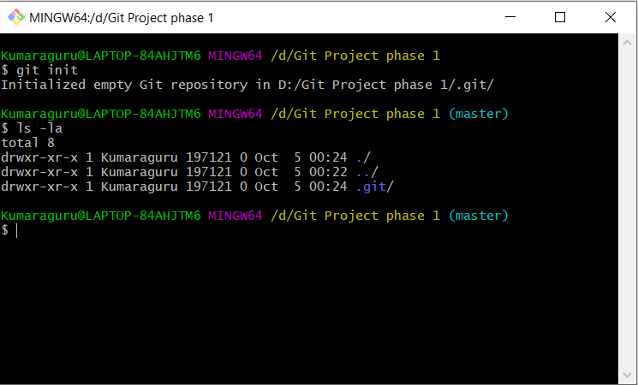

Command:

Git remote add origin “https://github.com/kumaraguru08/SimpliLearn_Java_Project1.git”:

To connect to the repository of the public using https link of the repository

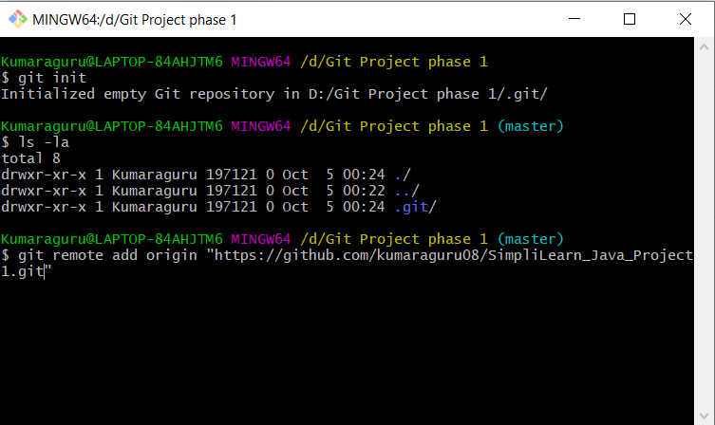

Command: Git pull origin master

To pull all the files from the repository

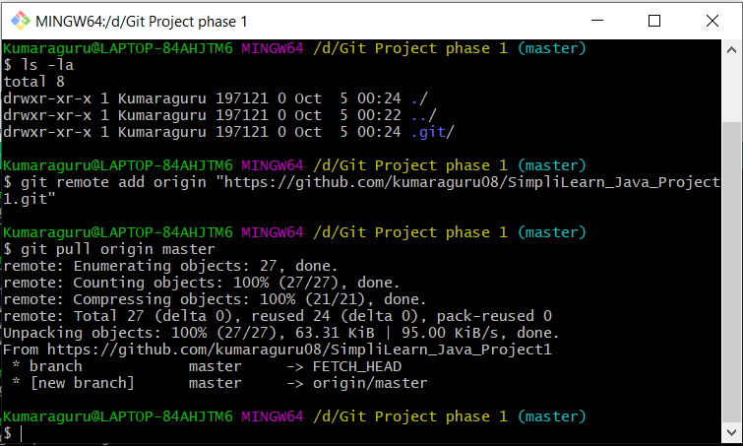

Here you will find all the files from the repository same as in git hub

Local after pull:

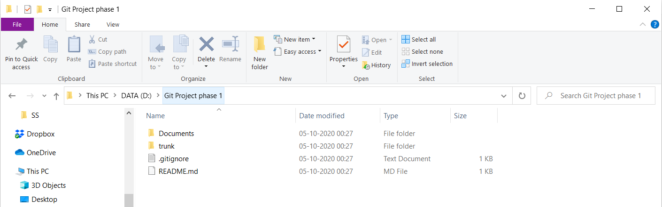

GitHub:

